Experiment No 7 : A/B Testing
Name : Prem Vijay Hanchate
Roll no : 68 Class : TE/IT

Aim
To design and conduct an A/B Testing experiment across two real-world digital scenarios — YouTube Thumbnail CTR and Webpage Design engagement — compare the performance of a control group (A) and a variant group (B) using Welch's two-sample t-test, compute effect size and confidence intervals, and determine which version performs better at a significance level of α = 0.05.
Theory
1. What is A/B Testing? A/B Testing is a controlled experiment used in digital product development, marketing, and UX design to compare two versions of a digital asset and determine which performs better on a defined metric. One group of users (Group A — Control) sees the existing version, while another group (Group B — Variant) sees the modified version. Statistical testing is then applied to determine whether the observed difference in performance is real or due to random chance.
A/B Testing is widely used for decisions such as which webpage layout retains users longer, which button color gets more clicks, which thumbnail drives higher engagement, or which app feature increases conversions.
2. Experimental Design: Each scenario in this experiment follows a consistent structure:
- Sample size — 100 users total: 50 in the Control group and 50 in the Variant group.
- Random assignment — Users are randomly assigned to groups to eliminate selection bias.
- Single metric — One clearly defined performance metric per scenario.
- Test — Welch's two-sample t-test, two-tailed, α = 0.05.
3. The Two Scenarios:
Scenario | Group A (Control) | Group B (Variant) | Metric
1. YouTube Thumbnail | Standard Thumbnail | Clickbait Thumbnail | Click-Through Rate (CTR)
2. Webpage Design | Graphic-Heavy Page | Simplified Page | Time Spent (seconds)

Scenario 1 tests whether a clickbait thumbnail generates a significantly higher CTR than a standard thumbnail. CTR is defined as clicks divided by impressions and takes a value between 0 and 1. Control group CTR follows a Beta distribution with mean ≈ 0.30; Variant group CTR follows a Beta distribution with mean ≈ 0.42.
Scenario 2 tests whether a simplified webpage keeps users engaged as long as a graphic-heavy one. Time spent on page (in seconds) is the metric. Control group (graphic-heavy) follows a Normal distribution with mean ≈ 180s; Variant group (simplified) follows a Normal distribution with mean ≈ 140s. Values are clipped to a realistic range of 10s to 400s.
4. Hypotheses: For both scenarios, the same hypothesis structure is followed:
- H₀ (Null Hypothesis) — There is no significant difference in the metric between the Control and Variant groups.
- H₁ (Alternative Hypothesis) — There is a significant difference in the metric between the Control and Variant groups.
- Test type — Two-tailed (difference in either direction is considered).
5. Welch's Two-Sample T-Test: A t-test is used to compare the means of two independent groups. Welch's variant (with equal_var=False) is preferred over Student's t-test because it does not assume equal variances between the two groups, making it a safer and more robust default for real-world A/B tests where the two groups may have different spreads.
The t-statistic is computed as:
t = (Mean_Variant − Mean_Control) / √(Var_Control/n_Control + Var_Variant/n_Variant)
Degrees of freedom are approximated using the Welch–Satterthwaite equation.
6. p-value and Decision Rule: The p-value represents the probability of observing a t-statistic as extreme as the one computed, assuming H₀ is true. The decision rule is:
Condition | Decision
p < 0.05 | Reject H₀ — statistically significant difference
p ≥ 0.05 | Fail to reject H₀ — no significant difference
7. Cohen's d — Effect Size: Statistical significance alone does not indicate the practical importance of a result. A very large dataset can produce a statistically significant result even for a trivially small difference. Cohen's d measures the practical magnitude of the difference:
Cohen's d = (Mean_Variant − Mean_Control) / Pooled_SD

Cohen's d | Effect Size
< 0.5 | Small
0.5 – 0.8 | Medium
> 0.8 | Large

A large Cohen's d alongside a significant p-value confirms that the difference is both statistically and practically meaningful.
8. Confidence Interval (95% CI): The 95% Confidence Interval gives a range of plausible values for the true difference between the two group means. It is computed as:
CI = (Mean_Variant − Mean_Control) ± t_critical × SE_difference
Interpretation:
- CI entirely above 0 — Variant is conclusively better.
- CI entirely below 0 — Control is conclusively better.
- CI crosses 0 — Difference is not conclusive, even if p < 0.05.
The CI provides richer information than the p-value alone and is a standard requirement in modern A/B test reporting.
9. Visualizations: Three panels are generated per scenario to communicate results clearly:
- Histogram — Shows the full distribution of the metric for both groups with mean lines overlaid. Reveals skewness, overlap, and where the bulk of values lie.
- Box Plot — Displays median, IQR, whiskers, and outliers for both groups side by side. Useful for comparing spread and identifying extreme values.
- Mean ± 95% CI Bar Chart — Plots the group means as bars with error bars representing the 95% CI. The p-value and significance label are included in the title for immediate readability.
10. Summary Table: A structured results table is generated for each scenario containing N, Mean, Std Dev, Standard Error, Min, Max, t-statistic, p-value, and the final decision (Reject H₀ / Do not reject H₀).

Execution
The following steps were performed for both scenarios:
Step 1 — Dataset Generation: Two datasets were synthetically generated using NumPy with a fixed random seed (42) for reproducibility:
- ab_youtube_dataset.csv — 100 rows, columns: user_id, group, thumbnail, ctr.
- ab_webpage_dataset.csv — 100 rows, columns: user_id, group, page_type, time_spent_s.
Each dataset contained 50 Control and 50 Variant records. Both were saved to CSV for reuse.
Step 2 — Group Splitting and Summary: Each dataset was split into Control and Variant series. Group-level descriptive statistics (mean, std, min, max) were printed to compare the two groups before formal testing.
Step 3 — Welch's T-Test: scipy.stats.ttest_ind() with equal_var=False was applied to compute the t-statistic and p-value for each scenario. Cohen's d was computed using the pooled standard deviation to quantify effect size.
Step 4 — Confidence Interval: The 95% CI for the difference in group means (Variant − Control) was computed using the t-critical value at α/2 = 0.025. The CI bounds were interpreted to determine whether the difference was conclusive in direction.
Step 5 — Visualizations: A three-panel figure was generated and saved for each scenario:
- ab_youtube_results.png — YouTube Thumbnail A/B test results.
- ab_webpage_results.png — Webpage Design A/B test results.
Step 6 — Summary Tables: Formatted summary DataFrames were constructed for both scenarios including all statistics, the t-statistic, p-value, and final decision row.

Hypotheses and Results:
Scenario 1 — YouTube Thumbnail CTR:
- H₀: CTR_Control = CTR_Variant (no difference)
- H₁: CTR_Control ≠ CTR_Variant (two-tailed)
- Control mean CTR ≈ 0.30 | Variant mean CTR ≈ 0.42
- (Paste your t-statistic, p-value, Cohen's d, and decision here)
Scenario 2 — Webpage Design Time Spent:
- H₀: Time_Control = Time_Variant (no difference)
- H₁: Time_Control ≠ Time_Variant (two-tailed)
- Control mean ≈ 180s | Variant mean ≈ 140s
- (Paste your t-statistic, p-value, Cohen's d, and decision here)

Output
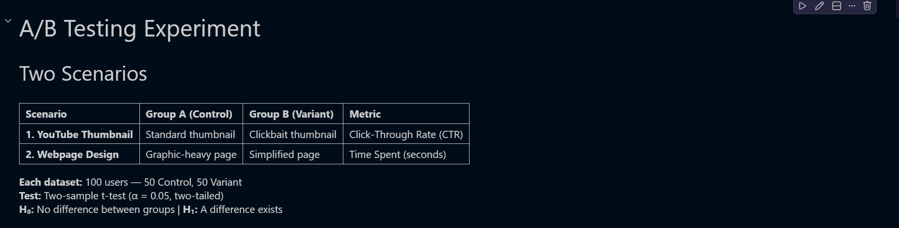
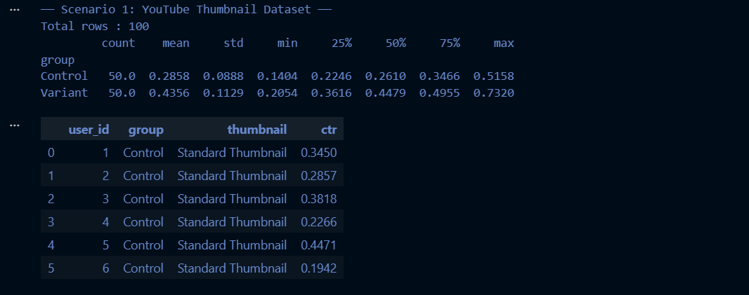
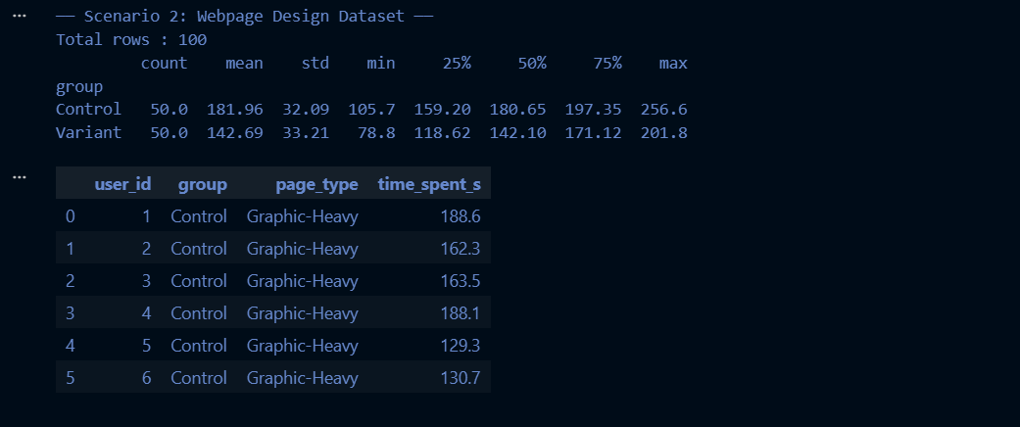


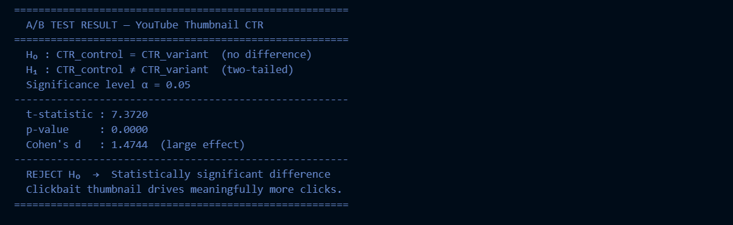
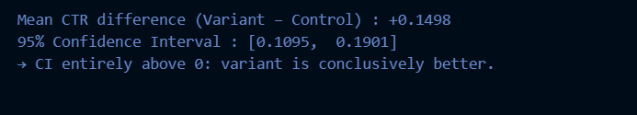
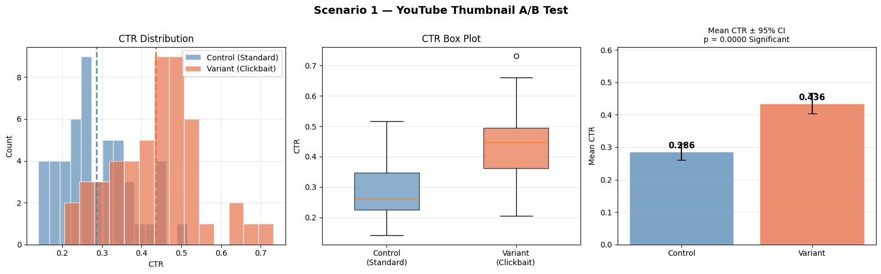
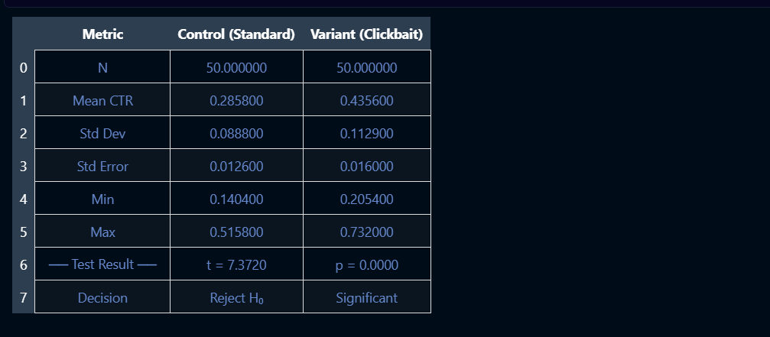

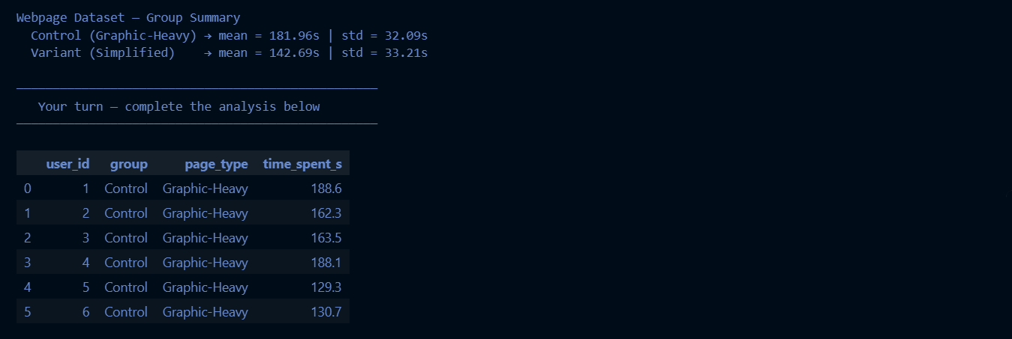
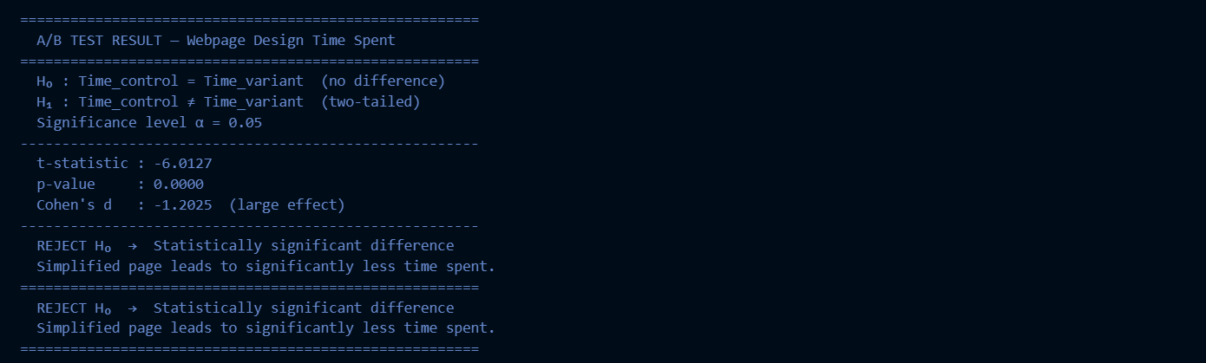
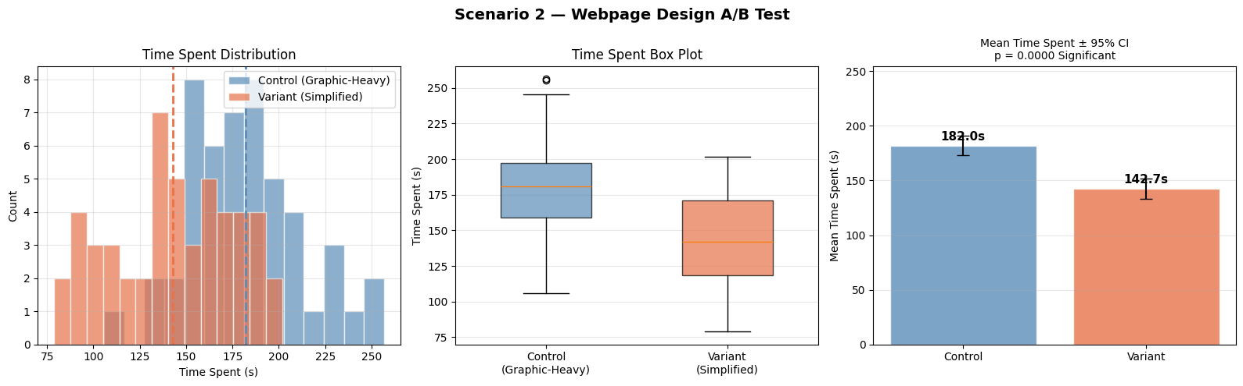
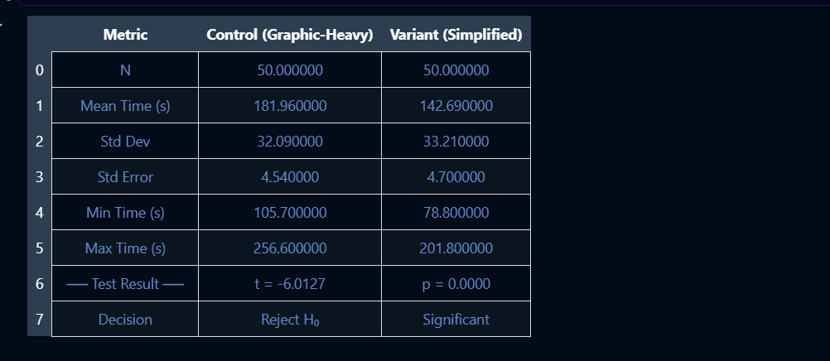
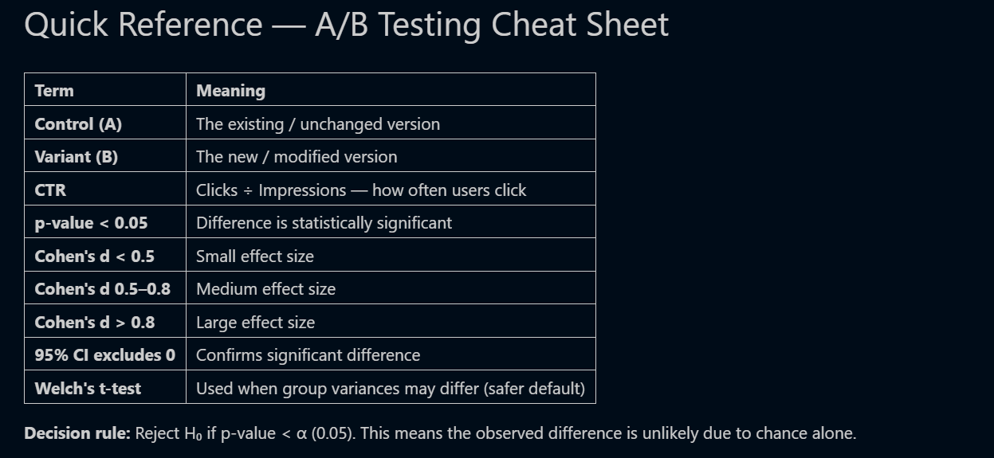

Conclusion
In this experiment, A/B Testing was performed on two digital scenarios using Welch’s two-sample t-test at α = 0.05. In the first scenario, the clickbait YouTube thumbnail showed a higher average CTR compared to the standard thumbnail. In the second scenario, the simplified webpage design showed lower engagement time compared to the graphic-heavy page. Statistical analysis, effect size, and confidence intervals were used to check whether the differences were meaningful. Visualizations like histograms, box plots, and bar charts helped in understanding the results clearly. Overall, the experiment showed how A/B testing helps in making data-driven business decisions with confidence.

